What do I need to know?
- Given a graph, identify the parent function.
- Given the equation of a function, know what the graph looks like
- Given an equation, be able to identify the domain, range, and x and y intercepts (if present).
- State the symmetry of the graph of the function. Is it even (y-axis symmetry) or odd (origin symmetry)?
- Given a real-world scenario, be able to state independent and dependent variables
- Given a real-world scenario, be able to state a reasonable domain and range.
REVIEW PROBLEMS:
- Which one of the following is the square root parent function?
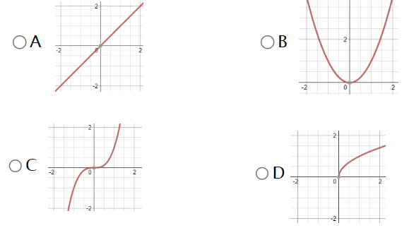

- Which one of the following is the quadratic parent function?
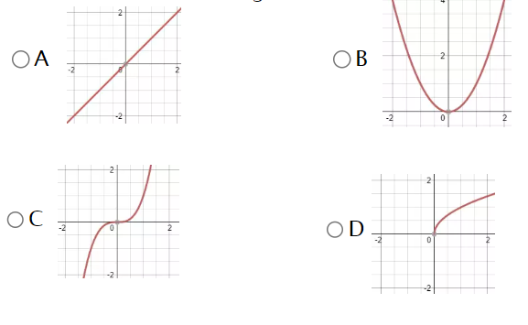

- Which of the following is the linear parent function?


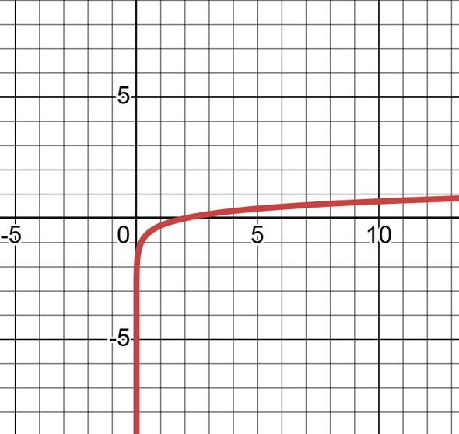
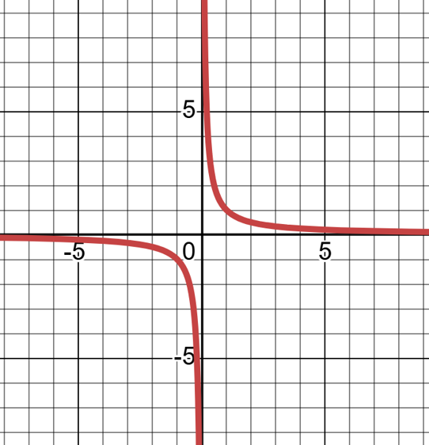
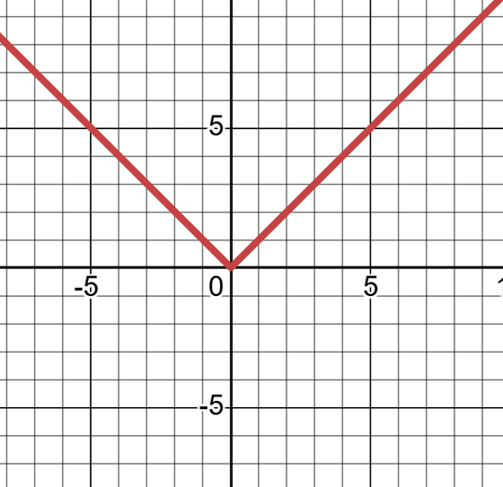
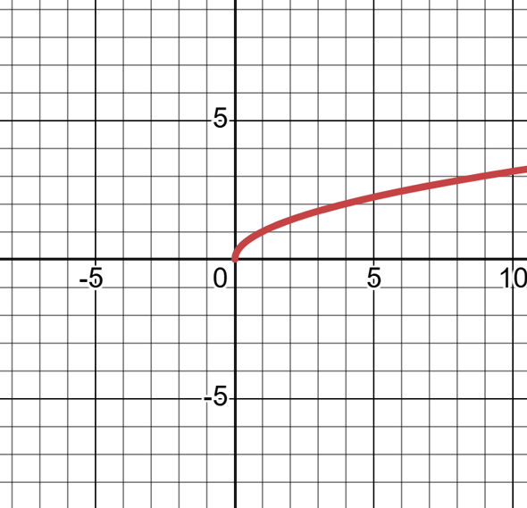
- Which of the following is the absolute value parent function?

- List the equations for all of the parent functions we are focusing on in this unit that have a domain of $x≥0$

- List the equations for all of the parent functions we are focusing on in this unit that have a range $y≥0$

- Which parent functions we are focusing on in this unit have symmetry about the origin?(Odd)

- Which parent functions we are focusing on in this unit have symmetry about the y-axis? (even)

- A phone company charges a base fee of $30 per month and an additional $0.10 for each text message sent. Let the total monthly cost be $C$ in dollars, and the number of text messages sent be $x$.
  - Identify the independent and dependent variables, and explain why.

  - State a reasonable domain and range for this situation

- The height $h$ of a sunflower (in centimeters) grows over time$t$ (in days) after it is planted. Suppose the sunflower grows at a constant rate of 2 cm per day for 50 days, then its growth slows to 0.5 cm per day for the next 30 days.
- Identify the independent and dependent variables.

- State a reasonable domain and range for this situation.

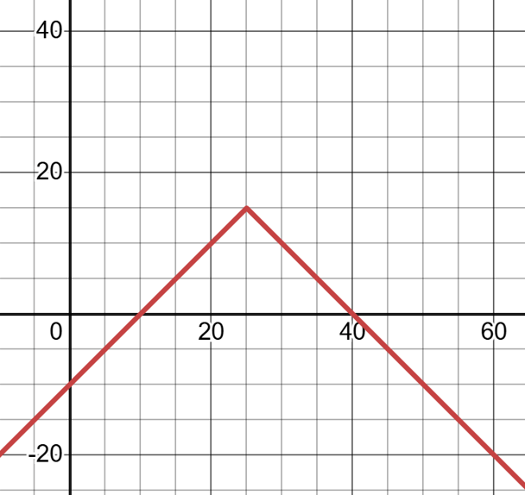
- A marine biologist is using a submersible to observe a pod of dolphins. She has a tracking system that measures her observation time based on the dolphin's depth relative to a reference point—a coral reef located at a depth of 25 feet. The equation $T=-\left|d-25\right|+15$ models the observation time, T, in minutes, given the dolphin's depth, d, in feet.

a. What is the function family of this equation? What features of the equation's structure indicate this?

b. What does the independent variable represent in this situation?

c. What does the dependent variable represent in this situation?

d. Find the intercepts of the graph and explain what they represent in the context of this situation.

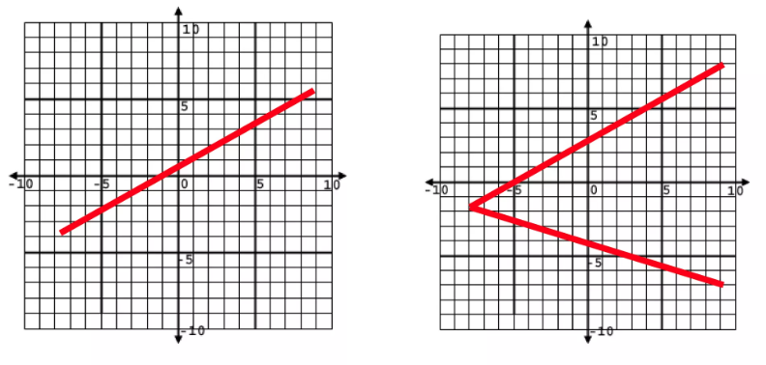
- Which one of these is not a function? Why?

- Julian, on the edge of sanity, launches his backpack up into the air from some stairs, which are 3 feet high. The graph below models the path of his backpack as it travels through the panhandle sky.
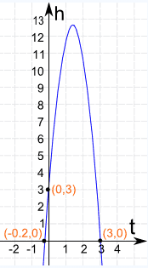
Analyze how long it takes his backpack to hit the ground.

- What does the domain represent?

- What does the range represent?

- What is a reasonable domain for the scenario?

- What is a reasonable range for the scenario?

- What are the intercepts and what do they represent in this situation?

15. The local taco drive-thru offers to pay new cooks $16 per hour plus $100 signing bonus. New employees at this restaurant are not allowed to work overtime for the first three months. Analyze the potential earnings of a new cook in the first week.
This situation can be modeled by the function $f(x)=16x+100$

a. Identify the independent variable within the context of this situation.

b. Identify the dependent variable within the context of this situation.

c. What would be reasonable values for a minimum and maximum for the independent variable? Explain your reasoning.

d. What would be reasonable values for a minimum and maximum for the dependent variable?Explain your reasoning.

e. Write the domain and range for the situation:

Inequality: ____________________________

Set: _________________________________

Interval: ______________________________

16. The high school track team wants to build a new warm-up track in the school courtyard. The principal has given the team permission to build a square track with the stipulation that it could not be larger than 121 square meters. The material to lay the track costs $15 per linear meter. The equation $C=60\sqrt{A}$​ represents the cost of the track, C, given the desired area, A.

- Name the function family. What aspects of the equation's structure indicate that it belongs to that family?

- Make a table to represent the situation.

- Use technology to graph the function. Sketch a graph below. Label the axes. Label any minimum and maximum values.

- Identify the independent variable in this situation.

- Identify the dependent variable in this situation.

- Are there any restrictions on the domain of this function?

- State the domain and range of this situation.

- Does this situation have a minimum? If so, explain its meaning within the context of the situation.

- Does this situation have a maximum? If so, explain its meaning within the context of the situation.

- Consider the limitations of this model. Describe a real-life restriction that might affect a club in this situation that was NOT addressed in the problem above.

